Choosing the right eyebrow shape for your face!
Eyebrow shapes and trends have always been popular beauty trends. And just when you think you have shaped your brows to match the trend, another eyebrow shape trend takes over!
So should we just be concerned about trends? Or it is more about what-suits-you-the-best? Gone are the days when one merely could try an eyebrow shape that was trending. It is now more about recognizing the shape of the face and complimenting it with the correct brow shape than it is what’s trending.
Know which celebrity face shape matches with yours and find out what eyebrow shape they flaunt that creates ripples in the world of beauty and fashion.
Eyebrows for a round face
Les Misérables star Lily Collins shares her eyebrow style for her round face.
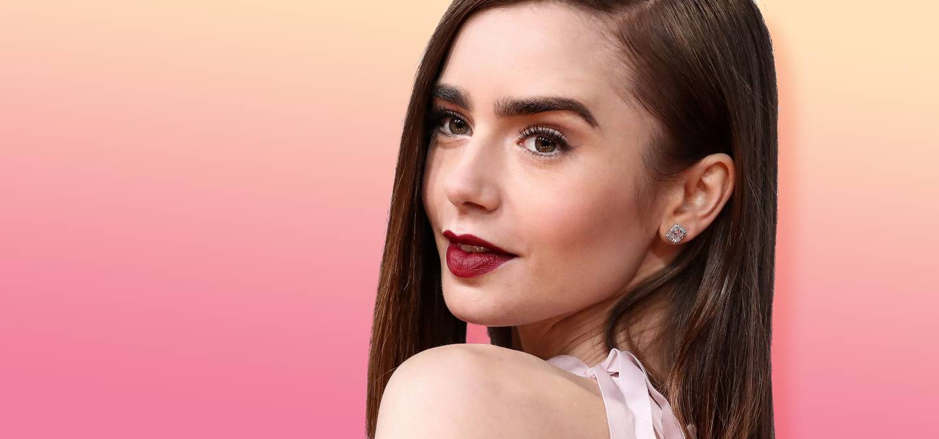
Image Source: shutterstock.com
Grow your brows full and do not over-pluck them. Keeping an arch, as sharp as it can be, gives your round face a dramatic look. Here is an important tip – to give your face a wider look - keep the arch away from the nose as much as possible.

Eyebrows for a long face
Image: Source: Getty / Valerie Macon/AFP
If you are someone with a face shape like Sarah Jessica Parker or Liv Tyler who are bestowed with a long face, the best eyebrow style for you is to avoid arches that are high. Straight shape the brow, keeping them fuller and then slightly arching them. This will compliment your face by making it looker wider.

Eyebrows for a diamond-shaped face

Image Source: Startraks
With a wider forehead and narrow jaw-line, celeb styling of Elizabeth Hurley, Ashley Green and Audrey Tauton is here for you. Keep the arch of the eyebrow angular and the brow neither too thin nor thick. The angular arch lends shape and length to the face.

So the next time you make an appointment for your eyebrow, do not forget your favorite celeb eyebrow style!

